LoRaTracker Receivers
Stuart Robinson

Receiver Options

The LoRaTracker transmitters are of little use without a receiver. There are several options here, including a fairly capable receiver based on a 1284P. There is also a Mikrobus socket based board intended to be used as a receiver with one of the 20x4 LCD displays.

However the the tracker transmitter boards such as the Locator2 board have been designed so that they can also be used as very small, compact and low cost receiver. All that’s needed is a suitable display.

SD1306 I2C OLED

The easiest of the display options is the SD1306 0.96” I2C OLED

To connect this display, you need only only 4 wires to connect to the Locator2 board as, GND, VCC, SCL and SDA as shown below with the display in large text mode;

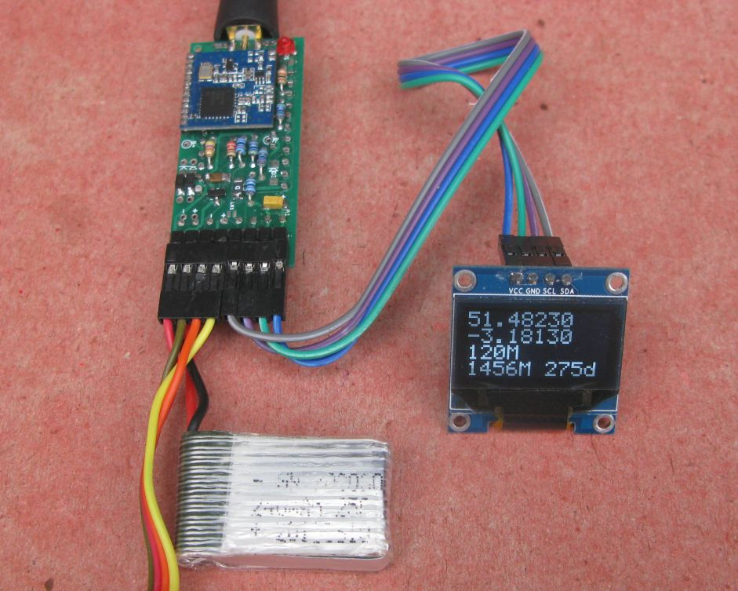

The connections from the Locator2 board to the SD1306 I2C OLED should be checked against the PCB layout diagram and schematic. There are at least two variations on the layout of connections on the SD1306, be sure to check the display you have. The one below is VCC,GND, SCL,SDA, in this picture the display is in small text mode,
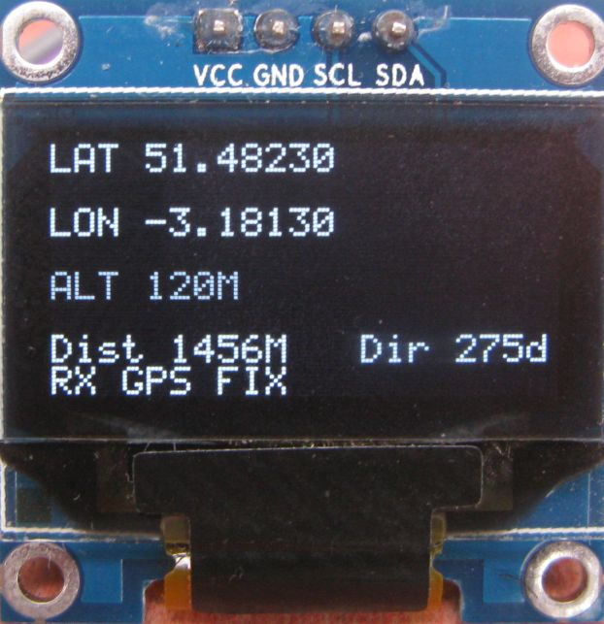

Load and run the ‘I2C_Scanner’ test program first. This should display on the Arduino serial monitor the following for a correctly built Locator2 board with the SD1306 I2C OLED connected correctly;

I2C Scanner
Scanning...
I2C device found at address 0x3C
I2C device found at address 0x50
I2C device found at address 0x51
I2C device found at address 0x52
I2C device found at address 0x53
I2C device found at address 0x54
I2C device found at address 0x55
I2C device found at address 0x56
I2C device found at address 0x57
done

0x3C indicates the SD1306 is connected correctly. If the display address is different then the address in the ‘Display_SD1306_AVR.h’ file in the LoRaTracker Library will need to be changed accordingly;

#define I2C_ADDRESS 0x3C //address will be 0x3C or 0x3D

The addresses 0x50 to 0x57 shown above indicates the I2C FRAM is connected and responding. Do not proceed until you have verified these addresses.

Once you have verified the above, from the Receiver1 Github repository, load and run the
‘SD1306_Display_Test’ program. This will verify that the display is properly working, ensure you confirm the working display before proceeding.

The SD1306 does only display a limited number of lines and characters, but its enough to display the trackers location and altitude. If the receiver has a GPS is fitted the distance and direction to the remote tracker is shown as well. The library used for the SD1306 is a text only library that uses very little memory.

20 x 4 I2C LCD Display
20 character 4 line LCDs based on the HD44780 controller are available inexpensively in eBay, and these large easy to read in bright sunlight displays are ideal for a tracker display. You need the high contrast yellow 3.3V display. Also at low cost you can get a PCF8574 I2C I\O expander board specifically designed to go on the back of these 20x4 LCD displays. Normally you need a minimum of 9 wires to drive the HD44780 controller but the I\O expander board reduces the connections to just 4. Since the receiver is already using the I2C interface bus for the FRAM, the display is in effect connected without using any extra I\O pins.

The pictures below are the front and rear of the 20x4 LCD display connected to the Locator2 board.

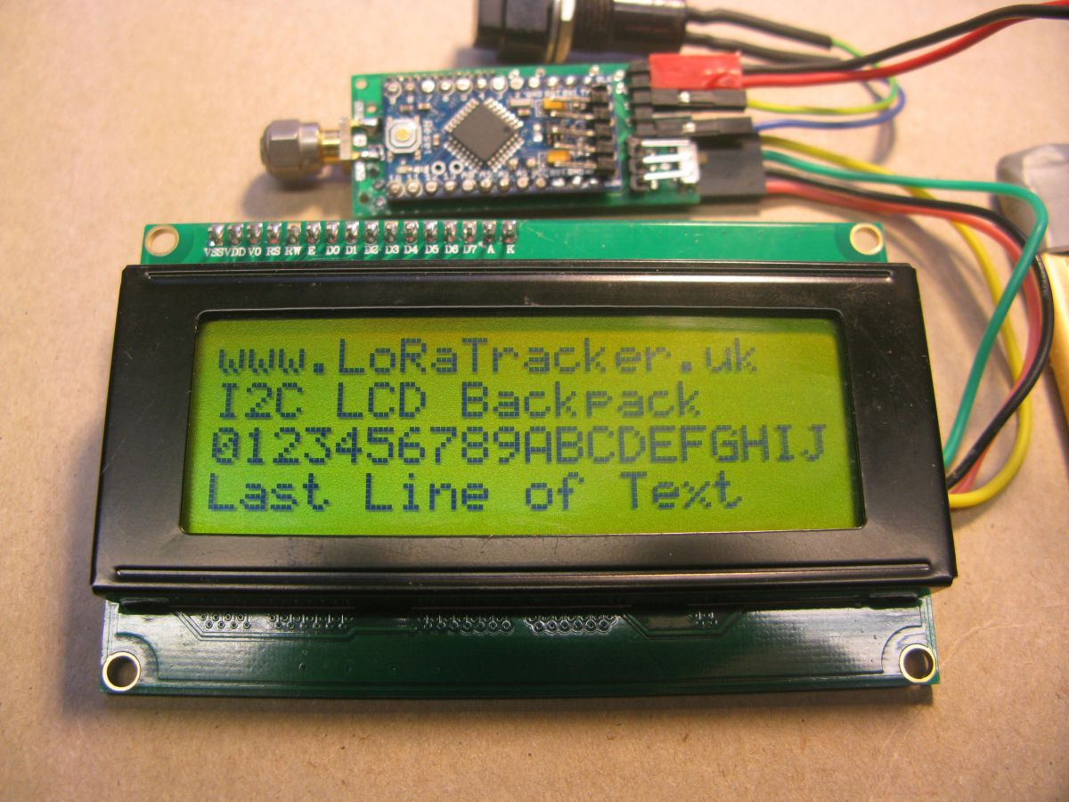

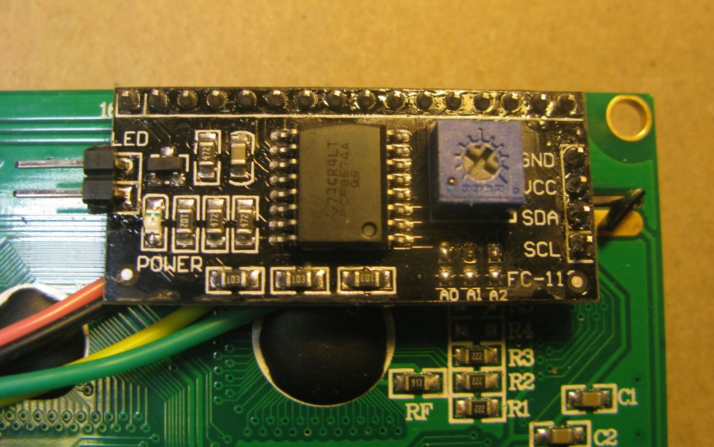

Load and run the ‘I2C_Scanner’ test program first. This should display on the Arduino serial monitor the following for a correctly built Locator2 board with the PCF8574 I2C I\O expander board connected correctly;

I2C Scanner
Scanning...
I2C device found at address 0x3F
I2C device found at address 0x50
I2C device found at address 0x51
I2C device found at address 0x52
I2C device found at address 0x53
I2C device found at address 0x54
I2C device found at address 0x55
I2C device found at address 0x56
I2C device found at address 0x57
Note the display address of 0x3F.
The Receiver1 repository has a test program for the 20x4 LCD, ‘I2C_20x4_LCD_Test’. Load and run this. You will need to adjust the contrast control on the PCF8574 I2C I\O expander board in order to see the characters on the display.

Connecting the Switch
The Locator2 tracker program has a number of options, the in-flight (not lost) transmissions are at one set of LoRa parameters which are enough for approx 100km line of sight, but when lost the tracker transmitter switches to a different slower set of LoRa parameters in order to significantly improve ground search range. To change the receiver and display between the different settings a single switch is needed. If the Locator2 board is being used as a receiver you need to wire the switch between CONA-4 and CONA-6. CONA-4 is where the RC Servo pulse would be read if the Locator2 board is being used as the tracker transmitter.

The connection of the switch, and SD1306 display is shown below;
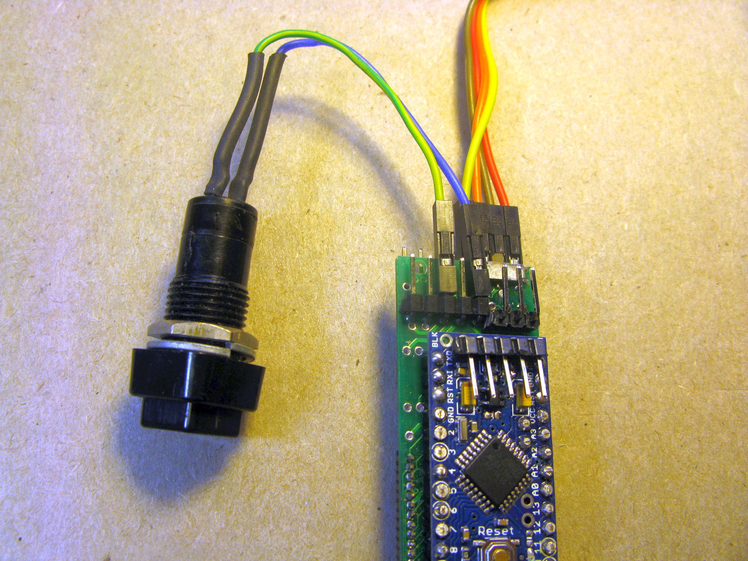

Programming the Receiver

Once you have the display connected, checked and working you can load the receiver program ‘Basic_Receiver_Portable’, which will be found in the Receiver1 repository on Github;

https://github.com/LoRaTracker/Receiver1

Initially load the receiver program with this option set in the
‘Basic_Receiver_Portable_Settings.h’ file;

#define ClearAllMemory

This will clear the I2C FRAM of any old information relating to configurations settings or tracker location.

Once the program is started memory will have been cleared and you can remove the ClearAllMemory setting and set the options as follows;

#define ConfigureDefaults
//#define ClearAllMemory

Reprogram the receiver. Note that at start up that ‘ClearAllMemory’ is now not defined, the two ‘//’ at the line start turn the define into just a comment.

The Locator2 board is light enough to be fitted in a box just using the edge SMA antenna connector to hold it in place.

Stuart Robinson

November 2017
www.LoRaTracker.uk

